PROG2002 WEB DEVELOPMENT II
Assessment 3 Project Report
UnityAid Charity Events
A dynamic charity event website with Angular 22 client and admin applications
Student | Liu Tao
Student ID | 24516824
Unit | PROG2002 Web Development II
Assessment | Assessment 3
Team | Group project (2 students)
Date | 18 October 2026
GitHub repository: 202200408040/PROG2002-A3-Charity-Events

1. Introduction and Motivation
UnityAid Charity Events is a dynamic website built for the PROG2002 Assessment 3 charity event case study. Visitors can browse current charity events, inspect the full details of an event, and register for one or more tickets. Staff use a separate administration website to create, edit and remove events. The two applications share the same MySQL database through a Node.js and Express REST API.
The project extends the Assessment 2 website in four ways. A registration page and registration API record attendee details and ticket numbers. The event detail page now lists every registration for that event, sorted by the latest registration date. A new admin application provides full CRUD control over events. Both front ends were rebuilt with Angular 22 and TypeScript so that the interface is component-based, typed and easier to maintain.

2. Problem Statement
A static charity website cannot keep event information reliable. Each change has to be copied into several pages, and there is no way to stop an event that has been suspended or has already finished from appearing on the home page. The Assessment 2 site solved the display problem by reading events from MySQL through an API, but it was still read-only. The public could not reserve a place at an event, and staff could not maintain the event catalogue without editing the database directly.
Registration also creates a data integrity problem. An event with registrations must not be deleted, because deleting it would remove the link between the event and its attendee records. The database and the API therefore need to enforce the relationship, not just the user interface. The design also needs to prevent the same person from registering twice for the same event while still allowing that person to register for different events.

3. Solution Overview
The solution uses a three-layer architecture. The presentation layer contains two Angular applications: a public client site and an admin site. The application layer is an Express server that exposes REST endpoints, validates input and runs parameterised MySQL queries. The data layer is the charityevents_db database, which stores organisations, categories, events and registrations.
Layer | Technology | Responsibility
Presentation | Angular 22, TypeScript, HTML, CSS | Public pages, admin pages, forms, validation messages and API calls
Application | Node.js 22, Express | REST routing, input validation, error handling and database access
Data | MySQL 8 | Persistent storage with primary keys, foreign keys and constraints
External service | Open-Meteo API | Weather forecast or current conditions for an event location

The public and admin applications are separate Angular projects inside one workspace. Shared models, API services and layout components live in shared libraries, so both applications use the same TypeScript interfaces and the same header, navigation and footer. This avoids duplicating code and keeps the two sites visually consistent.

4. Web User Experience

4.1 Public website
The home page introduces the charity and displays current and upcoming active events as cards. Each card shows an image, category, date, location, ticket price and a link to the detail page. The search page allows visitors to filter by date, location and category, either individually or in combination. The detail page loads one event by its ID, shows the full description, fundraising progress, ticket price and a weather panel, and lists the registrations for that event. The Register button opens a dedicated registration page for the selected event.
The registration page repeats the event summary so the visitor knows what they are booking. The form collects a name, email address, phone number and number of tickets. Invalid fields are shown next to the input, duplicate registrations return a clear message, and a successful submission displays a confirmation panel with a link back to the events page.

4.2 Admin website
The admin event list shows every event regardless of status. Active, past and suspended events are labelled separately, and the table includes the event name, date, category, location, registration count and total tickets sold. Each row has Edit and Delete actions. The create and edit forms use Angular Reactive Forms with required-field, length and numeric range validation. The edit form also shows the registrations attached to that event. When a delete is blocked because registrations exist, the list displays the API's 409 response as a clear error message instead of failing silently.

4.3 Shared layout and feedback
The header, navigation and footer are implemented once as shared Angular components and used by both applications. Every page follows the header, navigation, body and footer structure requested in the Assessment 2 feedback. Loading, empty, success and error states are displayed in the page, and the layout remains usable on narrow screens through responsive CSS.

5. Data Schema
The database is named charityevents_db and contains four tables. Organisations and categories each have a one-to-many relationship with events. Events have a one-to-many relationship with registrations. The events table stores the date, time, location, latitude, longitude, ticket price, fundraising goal and status needed by the public and admin pages. Latitude and longitude were added so the detail page can request weather data from Open-Meteo.

Figure 1. Entity relationship diagram for charityevents_db
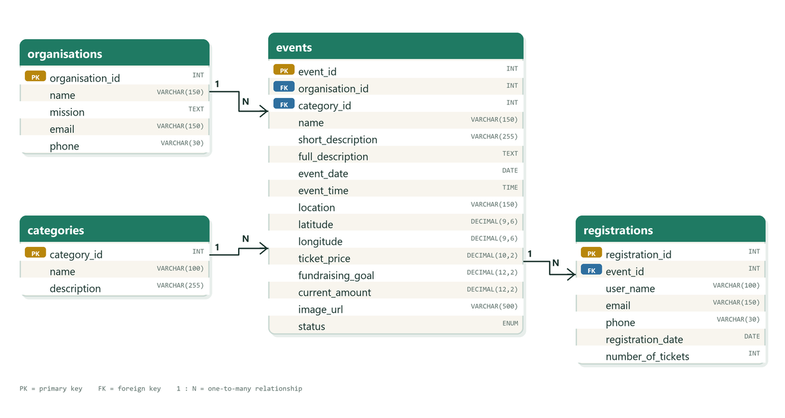
Each event belongs to one organisation and one category. Each registration belongs to one event. The unique constraint on (event_id, email) prevents duplicate registrations for the same event.

The registrations table stores the user's name, email, phone number, registration date and number of tickets. The event_id column is a foreign key to events. The unique constraint uq_registration_event_email prevents the same email address from registering twice for one event, while the same person may still register for other events. The check constraint chk_registration_tickets requires at least one ticket. The foreign key uses ON DELETE RESTRICT, so MySQL also protects registration history if an application bug attempts to remove a used event.
Table | Purpose | Key fields and constraints
organisations | Stores the charity that hosts events | PK organisation_id; name, mission, email, phone
categories | Stores event types used by search and admin forms | PK category_id; name UNIQUE, description
events | Stores the event catalogue | PK event_id; FK organisation_id, FK category_id; date, time, location, coordinates, price, goal, status
registrations | Stores attendee bookings for events | PK registration_id; FK event_id; UNIQUE(event_id, email); CHECK tickets > 0

The sample dataset contains five categories, eight events and ten registrations. The events include paid and free activities, a past event and a suspended event, so the home page filtering and the admin status display can both be tested with realistic data.

6. API Design
The Express API exposes public read endpoints and admin CRUD endpoints. All database access uses mysql2 prepared statements with placeholders, so user input is never concatenated into SQL. The API returns JSON and uses HTTP status codes to distinguish success, validation errors, missing resources and conflicts.
Method | Endpoint | Purpose | Success | Main errors
GET | /api/events/home | Current and upcoming active events for the home page | 200 | 500
GET | /api/categories | Category list for search and admin forms | 200 | 500
GET | /api/events | Search active events by optional date, location and category | 200 | 400, 500
GET | /api/events/:id | Event details, registrations, registration count and tickets sold | 200 | 400, 404, 500
POST | /api/registrations | Create a registration for an event | 201 | 400, 404, 409, 500
GET | /api/admin/events | All events with status, registration count and tickets sold | 200 | 500
GET | /api/admin/events/:id | One event with its registrations for editing | 200 | 400, 404, 500
POST | /api/events | Create a new event | 201 | 400, 500
PUT | /api/events/:id | Update an existing event | 200 | 400, 404, 500
DELETE | /api/events/:id | Delete an event only when it has no registrations | 200 | 400, 404, 409, 500

6.1 Search endpoint in detail
GET /api/events is the main search endpoint used by the public search page. It accepts three optional query parameters. When a parameter is omitted, that filter is not applied. This allows a visitor to search by one field or by any combination of fields without a separate endpoint for every case.
Parameter | Format | Validation
date | YYYY-MM-DD | Must be a real calendar date; invalid values return 400
location | Text | Trimmed and limited to 100 characters; matched with a partial, case-insensitive search
category | Positive integer | Must refer to a numeric category ID; invalid values return 400

Example request:
GET /api/events?date=2026-11-07&location=Lismore&category=2
Example response (one item from the JSON array):
[
{
"event_id": 2,
"name": "Hope Charity Gala Dinner",
"event_date": "2026-11-07",
"event_time": "18:30:00",
"location": "Lismore Community Hall",
"ticket_price": "120.00",
"category": "Gala Dinner"
}
]
The endpoint always excludes suspended events and orders results by event date, earliest first. If no record matches, it returns HTTP 200 with an empty array. This keeps the client logic simple: the page only needs to check the array length to decide whether to show results or the no-results message.

6.2 Create event endpoint in detail
POST /api/events accepts a JSON body with the organisation ID, category ID, event details, coordinates, ticket price, fundraising values, image URL and status. The API validates every field, checks that the organisation and category exist, inserts the row and returns the created event with HTTP 201.
{
"organisation_id": 1,
"category_id": 2,
"name": "Hope Charity Gala Dinner",
"short_description": "An evening of dinner, music and fundraising.",
"full_description": "A three-course dinner with live music and an auction.",
"event_date": "2026-11-07",
"event_time": "18:30:00",
"location": "Lismore Community Hall",
"latitude": -28.8139,
"longitude": 153.2792,
"ticket_price": 120.00,
"fundraising_goal": 25000.00,
"current_amount": 12800.00,
"image_url": "images/charity-gala.svg",
"status": "active"
}

6.3 HTTP method choices
GET is used for every read operation because it is safe and idempotent: repeating the request does not change the database. POST creates a new registration or event and returns 201. PUT replaces the editable fields of an existing event and returns 200. DELETE removes an event and returns 200 only when the operation succeeds. A delete request for an event with registrations returns 409 Conflict, which tells the admin interface that the request is valid but the current data state does not allow it.
Validation errors return 400 with a JSON message. Missing event IDs return 404. Duplicate registrations and blocked deletions return 409. Unexpected database errors return 500 without exposing SQL details. Authentication is not included because the assessment brief explicitly says it is not required, but a production deployment would need an admin login and role checks before exposing the write endpoints.

7. Registration and Admin Workflows

7.1 Registration flow
- The visitor opens an event detail page and selects Register.
- The Angular router opens events/:id/register and the registration component reads the event ID from the route.
- The component calls GET /api/events/:id and displays the event summary.
- The visitor enters a name, email, phone number and ticket count. Reactive Forms validation runs before submission.
- The component sends POST /api/registrations. The API validates the event, checks for a duplicate email and inserts the record.
- On success, the page shows a confirmation message and a link back to the event or home page. A duplicate returns 409 and a clear message.

7.2 Admin flow
- The admin opens /events and the page calls GET /api/admin/events.
- The list displays every event with its status, registration count and tickets sold.
- Create Event opens a blank Reactive Form that calls POST /api/events after validation.
- Edit opens /events/:id/edit, loads the event and its registrations, and calls PUT /api/events/:id on save.
- Delete calls DELETE /api/events/:id. A 409 response is shown as a clear message when registrations exist.

7.3 Data flow between Angular and the API
Each page component calls a typed Angular service instead of using fetch directly. The service uses HttpClient to send the request to a relative /api URL. During development, proxy.conf.json forwards that request to the Express server on port 3000. Express validates the input, runs a prepared MySQL query, and returns JSON. The service passes the response back to the component, which stores it in an Angular signal. The template reads the signal and renders the event cards, tables or detail panel. Loading and error signals control the messages shown while a request is in progress or when it fails.

8. Testing and Validation
The application was tested at the API level and through the running Angular sites. The admin CRUD flow was also tested with a temporary event that was created, updated and deleted, so the test did not leave unwanted data in the database.
Test | Expected result | Result
Home events endpoint | Only active current or upcoming events are returned | Passed
Search by date, location and category | Each filter works alone and in combination | Passed
Invalid search parameters | HTTP 400 with a JSON message | Passed
Event detail endpoint | Event details and registrations are returned in date order | Passed
Registration validation | Missing or invalid fields are rejected with 400 | Passed
Duplicate registration | HTTP 409 for the same email and event | Passed
Admin event list | All eight events, including past and suspended, are returned | Passed
Admin create, update and delete | 201, 200 and 200 responses; record removed | Passed
Delete event with registrations | HTTP 409 and no deletion | Passed
Angular production builds | clientside and adminside build without errors | Passed
Weather panel | Forecast or current conditions appear for the event location | Passed

9. Deployment Plan
Each team member must deploy both websites and the API to their own SCU cPanel account. The Angular production build creates static files in dist/clientside/browser and dist/adminside/browser. These folders are uploaded to the cPanel web root, and the Express API is registered as a Node.js application with the database environment variables set in the cPanel interface.
The Angular applications use relative /api URLs. The cPanel web server therefore needs to forward /api requests to the Node.js application so that the front ends and the API share one origin. This avoids hard-coding a host name in the compiled JavaScript and keeps the deployment portable between the two team members' accounts.
Item | Value
Public website URL | [add after cPanel deployment]
Admin website URL | [add after cPanel deployment]
API base URL | [add after cPanel deployment]
Database | charityevents_db imported from charityevents_db.sql

10. Limitations and Future Work
The admin site has no authentication because the brief does not require it. In a real deployment, the write endpoints would need a staff login, role checks and an audit log. Registration does not take payment; it records a booking and the number of tickets requested. The weather panel is informational and should not be treated as a safety warning. The event list is not paginated, which is acceptable for the sample dataset but would need to change for a large catalogue.
Future work would add staff authentication, payment or donation processing, confirmation emails, cancellation and waitlist handling, and server-side pagination for the admin list. A production version would also add automated API tests and database migrations rather than importing a single SQL file.

11. GenAI Use Declaration
I acknowledge that I have used GenAI tools to complete this assessment. I used ChatGPT and Codex to brainstorm ideas, check grammar, improve clarity, and format this document within the parameters outlined in the Assessment Brief and by the Unit Assessor. I reviewed the final text and tested the application myself.

12. Academic Integrity Declaration
I declare that I have read and understood SCU's Academic Integrity policies and referencing guidelines. I am aware of the consequences of academic misconduct and confirm that this submission is my own original work, has been referenced appropriately, and has not been previously submitted. I authorise its reproduction for authentication purposes and understand the implications of a false declaration. I have adhered to the guidelines regarding Generative AI.

Appendix A. Repository and Local Run Instructions
GitHub repository: https://github.com/202200408040/PROG2002-A3-Charity-Events
- Import the database:
mysql -u root -p < TaoLiuA3-api/database/charityevents_db.sql
- Start the API:
cd TaoLiuA3-api
npm install
node server.js
- Start the public and admin Angular applications:
cd charity-events-angular
npm install
npx ng serve clientside --port 4200
npx ng serve adminside --port 4201
The public site runs at http://localhost:4200 and the admin site runs at http://localhost:4201. The API runs at http://localhost:3000. The .env file containing the local MySQL password is excluded from the repository.

